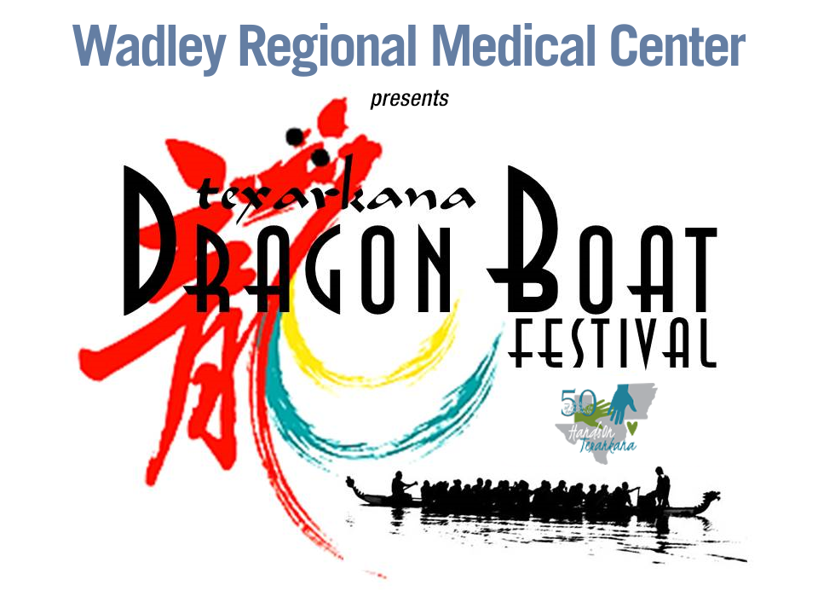
VENDOR FORM
HandsOn Texarkana’s Annual
TEXARKANA DRAGON BOAT FESTIVAL
Saturday, June 11, 2022 9am – 4pm
Bringle Lake Park, Texarkana, Texas

Registration Deadline is June 1, 2022

Vendor Booth Space approximately 20’ wide x 10’ deep
Vendor is responsible for all set up
Vendor set up beginning 7:00 a.m. Open to the public 9:00 am - 5:00 pm

(Please Print)
Vendor’s name: _______________________________ Cell phone _________________
Business name: __________________________________________________________
Physical address: ________________________________________________________
City/state/zip __________________________________________________________

Type of wares to be sold: _______________________________________________________________________

Please check one:

_____ Food Vendor fee - $125.00 _____ Non-food Vendor fee - $100.00

Make checks payable to HandsOn Texarkana
Mail form, copy of driver’s license, and payment to:
HandsOn Texarkana
P.O. Box 3173
Texarkana, Texas 75504

PayPal invoices are available at your request to pay online
Venmo payments: @HandsOn-Texarkana (please add Dragon Boat Vendor in subject)
Fax Form to: 903-798-3213 Email Form to: handsontxk@aol.com

- Please attach a copy of your driver’s license
- Food vendors must get a permit from the City of Texarkana, Texas
- Vendor fees are non-refundable

